|  |  |  |
| --- | --- | --- |
| **CS 112, Foundations of CS**  **lab 4: Functions**  **Submit to Canvas** | | **Computer Science** |
|  |  | |

This lab is worth 100 points. The goals for this lab are:

1. **Practice calling functions which you didn’t write**
2. **Write and call your own functions**

If you do not complete the lab in the time allotted, then please return to the lab in your spare time, and complete it by the **due date, which is specified on Canvas**.

**Preliminaries**

* For this lab, create another folder, called **lab4.**
* Navigate to the *winpython* folder on your computer. The path to the folder is the following: **C:\bin\winpython.** If you need help getting to the folder please refer back to lab 1. Once inside the *winpython* folder double click on “Spyder” icon and it will open up the Spyder IDE.

1. **Calling Functions**

For this programing task go to Canvas, from the lab4 directory download the file ***CallingFunctions.py***. This file will contains a few already completed functions. You will call those functions in the correct order and will pass to them the required parameters. This will help you get familiar with calling functions which you did not write. All you have to worry about is passing the correct parameters to them and check the return type. This part is worth 30 points.

1. To get started download the file named ***CallingFunctions.py*** from Canvas.
2. In the comment section on top, include your name, todays date and program name (lab 4, Calling Functions.py).
3. Create a list by calling the appropriate function. Your list should have numbers which are multiplies of 3 in the range between 3 and 50.
4. Call a function to print out the created list.
5. Call a function to get the min value and its index location.
6. Call a function to get the max value and its index location.
7. Call a function to print out the min value and its index location.
8. Call a function to print out the max value and its index location.
9. This can all be completed in 6 lines of code. Sample outputs can be seen below.

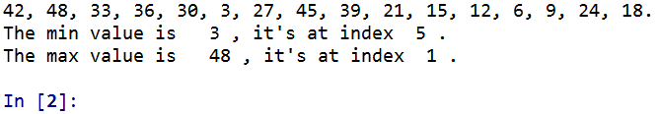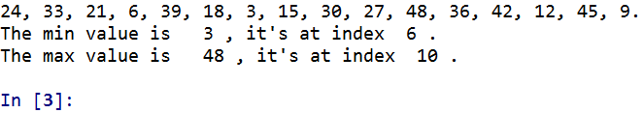

1. **Writing your own functions**

For this programing task you will write your own functions and call them. This will help you gain some experience of writing your own functions. This part is worth 70 points.

1. To get started create a new python file (mouse-click on the *File* menu, then select *New file*).If you need help please ask or refer to lab 1.
2. In the comment section on top, include your name, todays date and program name (lab 4, MyOwnFunctions.py).
3. Write a function to create a list of consecutive numbers (1,2,3,4,5..) between 1 and 13 inclusive. This can be done with the help of the range function. The function should return a list. You chose what to name the function. Refer to the lecture slides and the first part of this labs for hints.
4. Write a function to sum all of the elements inside of the list created by the function in step #3. Your function for this step should return the result for adding all of the elements in the list.
5. Write another function to multiply all of the elements inside of the list created by the function in step #3. This function is very similar to the function you defined in step #4.
6. Write one more function which prints out all of the even numbers from your created list. This can be done a few different ways, one way is to check if an element % 2 == 0. If it does then it’s an even number and print it out. This function does not return anything.
7. Create a list by calling your function. Print out the result for adding all of the elements together in the list. Print out the result for multiply all of the elements together in the list. Call a function to print out all of the even elements from the list.
8. In total you should have 4 functions. Call them to check if they work properly. Sample output can be seen below.

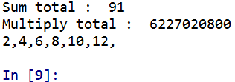

**Rubric**

Upload your source code to Canvas. Here's what we are looking for, when grading your submission

The .py files must be thoroughly commented. If your code breaks (crashes) because you've been unable to fix a syntax error, then the comments will allow you to receive partial credit.

For this lab, make sure that the following files are uploaded to Canvas:

*CallingFunctions.py*

*MyOwnFunctions.py*

|  |  |
| --- | --- |
| **File / task** | **Points** |
| 1. **CallingFunctions.py** | 30 |
| 1. **MyOwnFunctions.py** | 70 |
| Total | 100 |